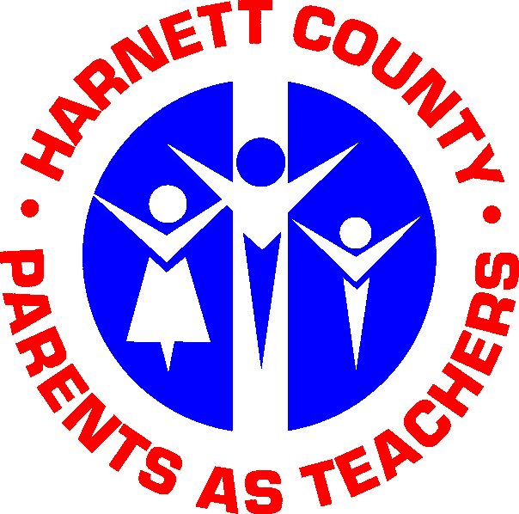

Parent
Handbook

2011-2012

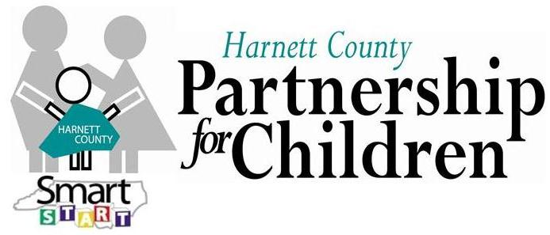

North Carolina State University and North Carolina A&T State University commit themselves to positive action to secure equal opportunity regardless of race, color, creed, national origin, religion, sex, age, veteran status, or disability. In addition, the two Universities welcome all persons without regard to sexual orientation.

Parent Handbook
Table of Contents

- Welcome to Harnett County Parents As Teachers

- What is HCPAT?

- PAT: A program that works!!!

- Your Baby’s Amazing Brain

- What you can expect from HCPAT

- How you can help HCPAT

- Your Role as a Parent

- Guidelines for HCPAT Families

- Guidelines for Group Participation

- Screening Policy

- Exit Policy

- HCPAT Contact Information

Dear Harnett County Parents As Teachers Family,

Welcome! We are excited that your family has decided to enroll in the PAT program.

We hope that each family will gain insight and knowledge into the rapid development of their child from birth to age five. We want to provide you with the most current information in both our county as well as across the state regarding kindergarten readiness. This opportunity will be both rewarding and fun for you and your children.

Educators and other PAT Staff look forward to becoming a partner with your family in walking your child down a positive educational track beginning at birth.

We have provided this handbook to assist you in understanding the PAT program as well as inform you of ways that you can participate in the program. We hope this will help you as we work together to provide the best opportunities for our children in Harnett County.

We always welcome parent feedback. Please do not hesitate to contact us with any questions, comments, or concerns that you have regarding our program or events that we are having.

You have my best wishes for a happy and successful venture down the path that ends at all children being ready and equipped to start kindergarten. Let me know if I can be of assistance to you or your family.

Respectfully,

Melanie Graham
Program Coordinator/Educator
Harnett County Parents As Teachers

What is
Harnett County Parents As Teachers?

Your child begins learning at birth. Parents As Teachers (PAT) can help you give your child the best possible start in life. PAT is a voluntary family education and support program that begins with the expectant mother and extends to age 5. The program is based on truths that parents are the first and most influential teachers of their children and that the early years lay the foundation for a child’s success in school and in life. You, the parent, are the teacher. In PAT, you are supported by certified parent educators who suggest ways you can effectively teach and nurture your child.

PAT is supported by Harnett County Cooperative Extension and funded by Harnett County Partnership for Children. It is free to all participants through funding allocated to North Carolina SmartStart from tax payer dollars.

Your family will receive monthly personal visits from a certified parent educator. Also, an invitation to participate in group meetings and events, screenings for each child administered yearly, connections with community resources, monthly newsletters and suggested family activities and materials.

PAT: A program that works!!!
“By promoting good brain development and positive parenting, PAT sets children on successful educational paths, ultimately leading to decreased public spending and stronger communities.” NC PAT Network

PAT Children are:
Significantly more advanced than comparison children in language, social development, problem solving and other cognitive abilities by age 3.
Scoring higher on kindergarten readiness tests and on standardized measures of achievement in the early grades.
PAT Parents are:
More knowledgeable about child-rearing practices and child-development.
More confident in their parenting skills.
Engaged in more language & literacy promoting behaviors with their children.
Are more involved in their children’s schooling.

What you can expect from
Harnett County Parents As Teachers:

- We will share with you what you can reasonably expect of your child at each stage of development.
- We will help you be a good observer of your child.
- We will help you have fun playing with your child, and show you age appropriate activities and provide materials for you to use.
- We will provide a variety of group activities for both you and your child to participate in and interact with other parents and children of similar age.
- We will respect you in your positive parenting decisions.
- We will schedule visits at a time that is convenient for you within reason. Office hours are from 8-5 but we can accommodate other hours for visits as needed.
- We will provide yearly screenings to your child to assess your child’s overall development. See Screening Policy for a further explanation of this process.
- We will help you be your child’s first and most important teacher.

How you can help PAT:

- Allow us to make regularly scheduled visits, usually in your home.
- Participate is group meetings and PAT activities.
- Be considerate about keeping appointments, if you cannot keep a scheduled appointment; please notify us ahead of time. We pledge to do the same for you.
- Be willing to provide a quiet place for the visit. Turn off the TV and radio.
- Remove anything that might be distracting, including pets.
- Both Parent and Child should be appropriately dressed for the visit to be conducted. Clothing should not be a distraction for parent, child, or educator.
- Join the parent educator and your child in play.
- Share what you have observed about your child since the last visit.
- Do whatever is necessary to meet the needs of your child during the personal visit.
- Share your interests and talents.
- Inform and provide documentation of your child’s immunization updates.

Guidelines for Families*:
(*Guidelines are put in place to ensure that all families receive comparable treatment in the following situations.)

- Visit appointments must be made and kept monthly. Educators have been advised that monthly visits are critical to the success of P.A.T. and they will be held accountable for that. If three consecutive months are missed without appropriate explanation an educator will exit the family from the program. See Exit Policy for a further explanation of this process.

- Harnett County PAT is funded by Harnett County Partnership for Children. The funding agency requires an accurate evaluation of the program’s effectiveness. Information will be reported to this agency collectively with no identifying information attached. Program records are monitored periodically.

- Parent Educators are responsible for teaching an educational lesson during a visit, if personal family concerns are expressed educators become liable for those issues and they will respond appropriately* as needed.
*Appropriately is defined as reporting to the program coordinator or a referral to a community service such as mental health, Department of Social Services, etc.

- If a family is exited from the program and they choose to re-enroll at a later time they will be placed on the waiting list if necessary. Previous Educators will not necessarily be able to immediately start visiting the family again.

- If your child or any family member in the home is sick (such as cold, fever, flu, or vomiting) a visit will be rescheduled for another day. If educators are not made aware of sickness before they arrive to the visit, they are to leave immediately after finding out about the sickness.

- Visits will not be conducted when Harnett County School System is closed due to bad weather such as snow, hurricanes, etc.

Guidelines for Group Participation*:
*Guidelines are put in place to ensure that all families receive comparable treatment when participating in group activities sponsored by Parents As Teachers.

- When arriving to the event, please gather for a brief introduction to the activity and a welcome from the PAT staff.

- Pay close attention to all safety guidelines set forth at each event.

- Turn off cell phones during events. This is to be respectful of other parents, children, speakers, and staff participating in an event.

- Monitor your children during the event. PAT Staff will not be responsible for meeting the needs of your children unless specified during the advertisement of the event.

- Clean up your area after participating in the event. This includes any food items and supplies used.

- PAT staff is not responsible for personal belongings or the loss of those items during events.

- Complete the evaluation provided at the end of the event.

Screening Policy

Each active* child enrolled in Parents As Teachers will receive a screening conducted by a trained Parent Educator.
*Active is defined as a family that is visited on a regular monthly basis.

The screening is a quick and effective way to look at your child in comparison with other children his/her age. It can determine whether or not your child is developing within the normal range for his/her age as well as identify possible areas of development to focus on during visits. The screening involves gathering health, hearing, vision, and developmental information. Information will be provided to you before each screening is done but don’t hesitate to ask your educator if you have questions regarding this process. Feedback will also be given to parents in regards to the screening results. Family members are an integral part of the process.

An initial screening will be conducted shortly after enrollment or after a child is four months of age. All other screenings will be conducted yearly around the child’s birth date.

Exit Policy

Consistent monthly visits are critical to the success of Parents As Teachers. If you and your family do not feel that the program is able to meet your needs please advise your parent educator or contact the program coordinator to discontinue service. This will consist of a brief exit interview/summary for our records to show closure with a family.

If we lose contact with your family for three consecutive months without appropriate explanation you will be exited from the program.

The educator will send a letter one month after contact is lost to the last known address and give the family one month to respond. If no response is received the educator will send one final notice to a family stating that they are exited from the program. A copy of each of these letters will be kept on file at the PAT office.

Due to extenuating circumstances, if a family can no longer be served by an educator, the family will be contacted by the program coordinator for an explanation of the immediate dismissal from the program. If contact can not be made by the program coordinator, letters will be sent as described above.

Contact Information

Harnett County Parents As Teachers
126 Alexander Drive
Lillington, NC 27546
(910) 814-6050

Melanie Graham
Program Coordinator/Educator
mgraham@harnett.org
(910) 814-6040

Torrey Vest
Administrative Assistant
tvest@harnett.org
(910) 814-6044

Shelly Humphrey
Parent Educator
shumphrey@harnett.org
(910) 814-6041

Christina Jolly
Parent Educator
cjolly@harnett.org
(910) 814-6042

Charmell McLean-Kelly
Parent Educator
cmkelly@harnett.org
(910) 814-6043

